Multispectral Data Visualization in QGIS

Taylor Nelsen

March 20, 2019

# Introduction:

This SOP walks through how to turn drone images maps for communication in QGIS. The final output will be similar to the map below:

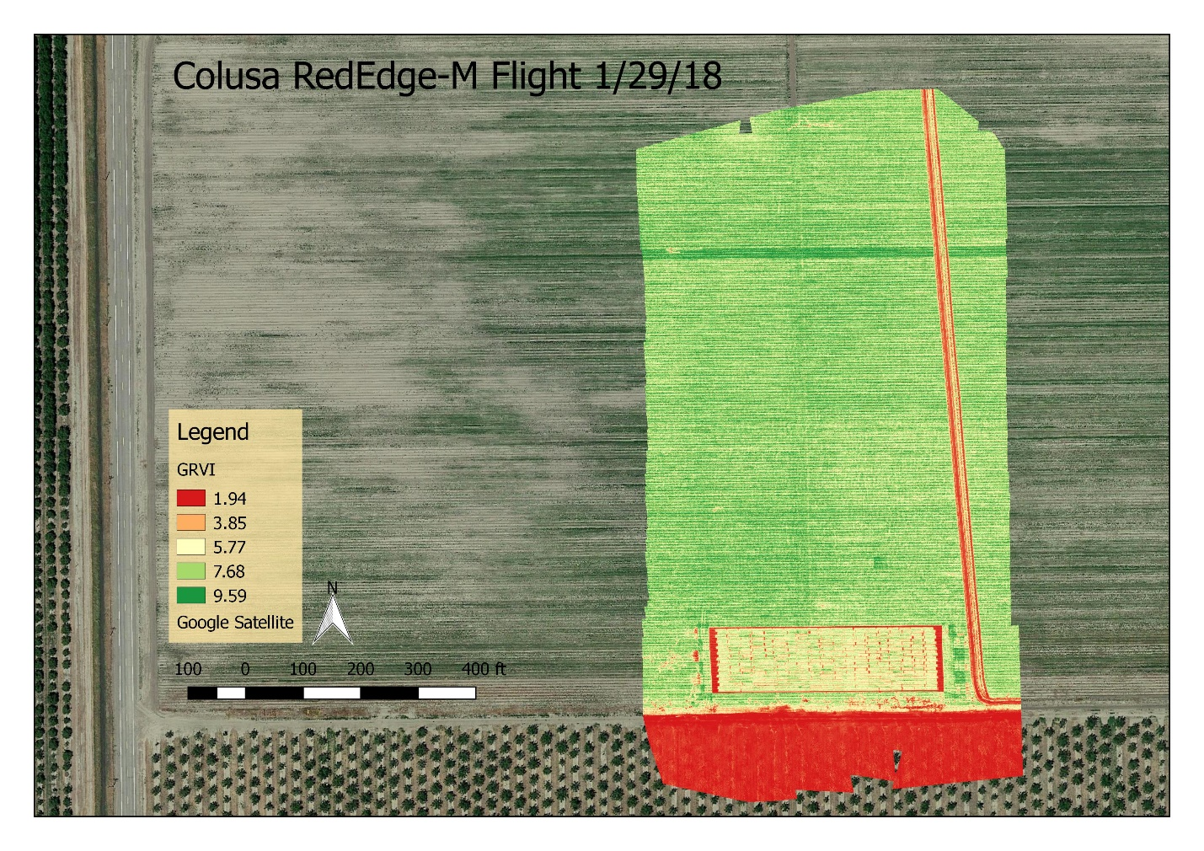

1. Open QGIS Desktop 2.18
2. Under the “Project” tab select “New” to create a new project.

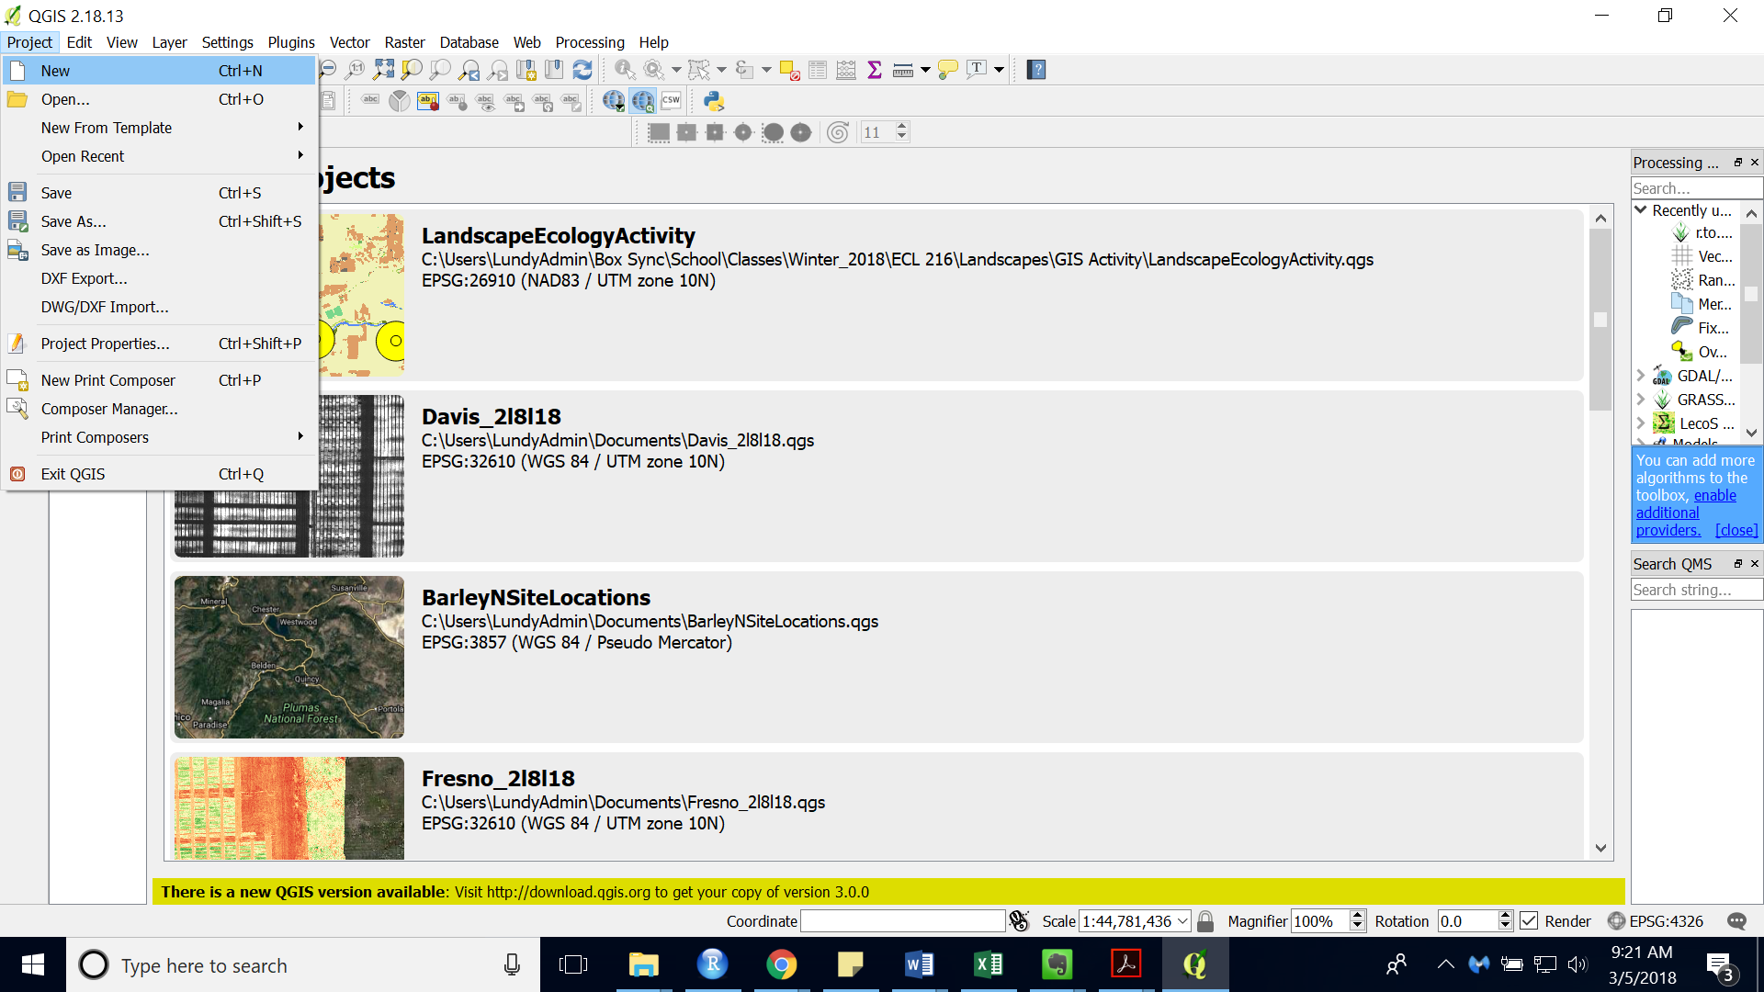

1. Under the “Project” tab select “Save As” to save the project. Regularly save your project while editing.
2. Add a background images through the “QuickMapServices” Plugin
   * To install navigate to: “Plugins” > “Manage and Install Plugins…”
   * Search “QuickMapServices” and “Install Plugins”
   * Navigate to “Web” > “QuickMapServices..” and choose “OSM” > “OSM Standard”
3. Add a raster layer by clicking on the checkerboard button on the left sidebar.

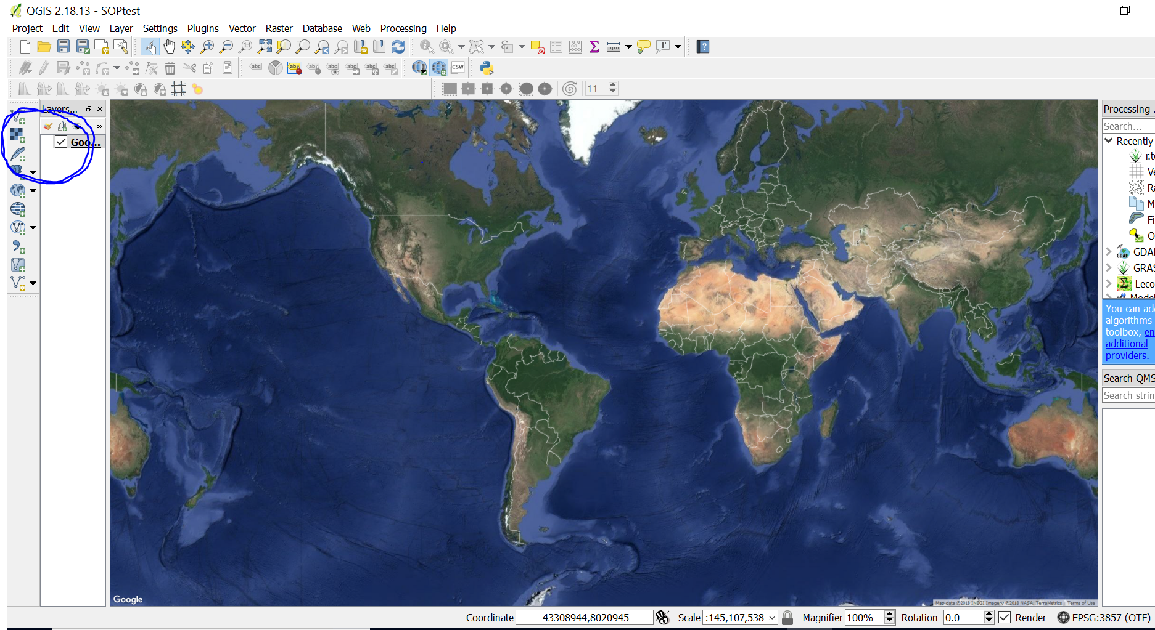

1. Navigate to your saved raster image.
2. Choose the image you wish to map and open it.
3. In QGIS the image should appear as a layer in the layers panel on the left.
4. Right click the image layer and choose “Zoom to Layer”

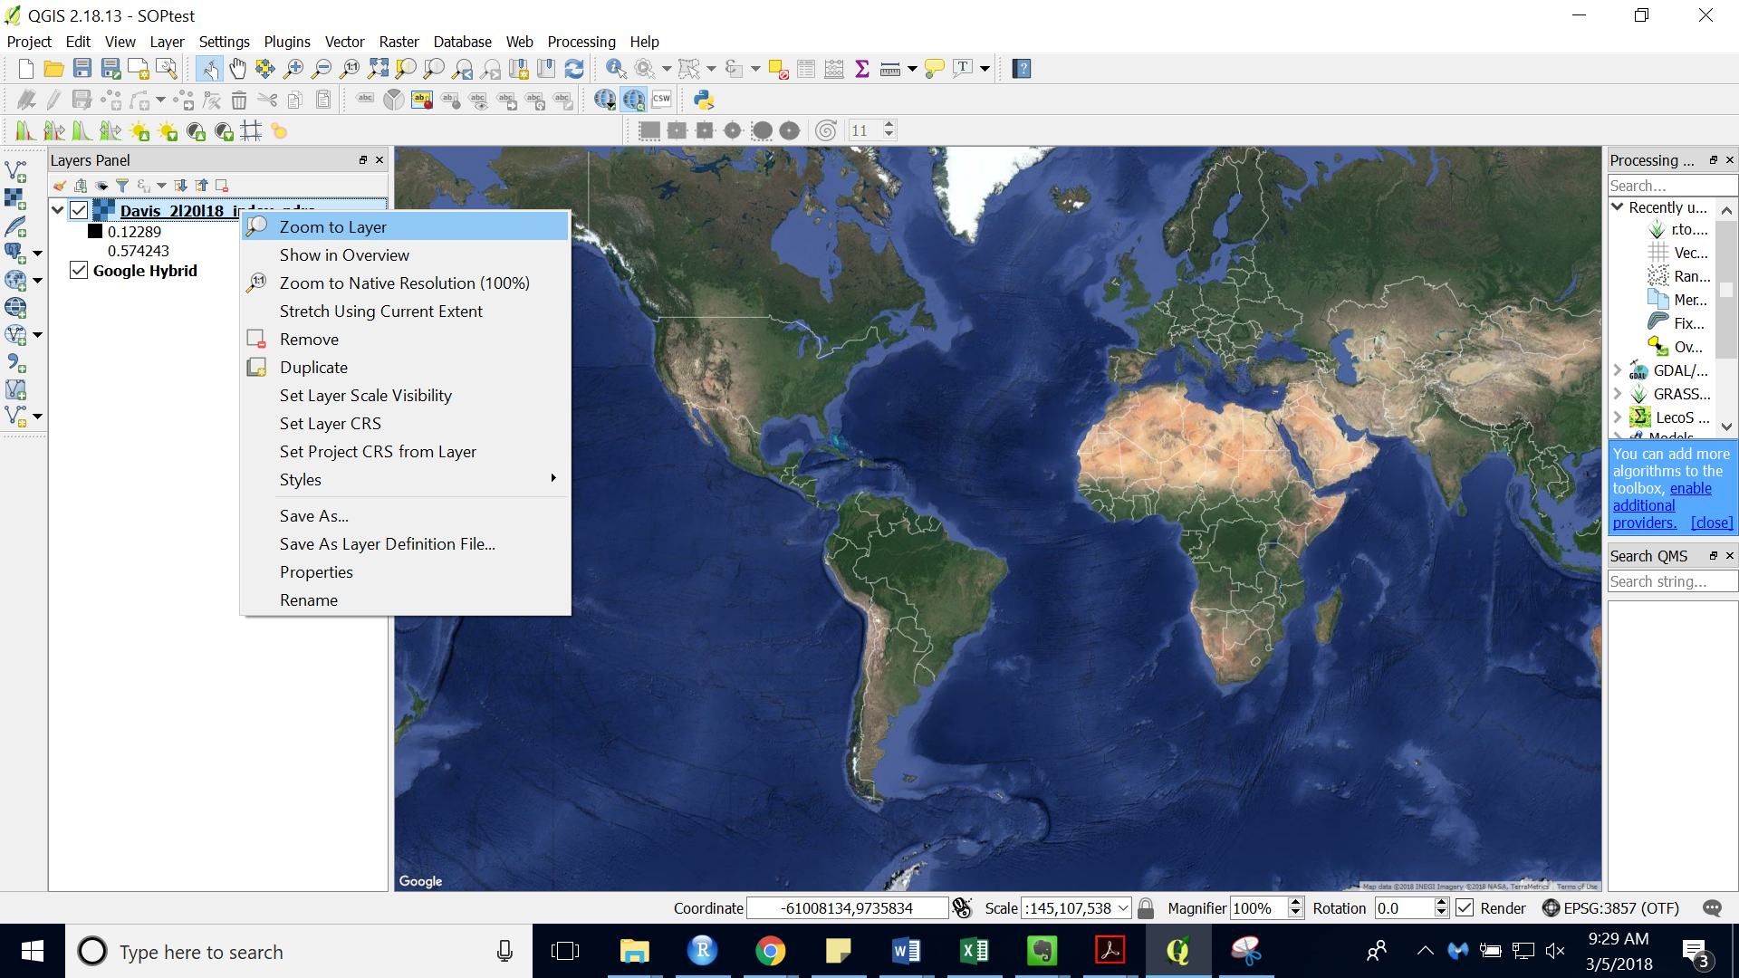

1. You should now see a grayscale version of your image.

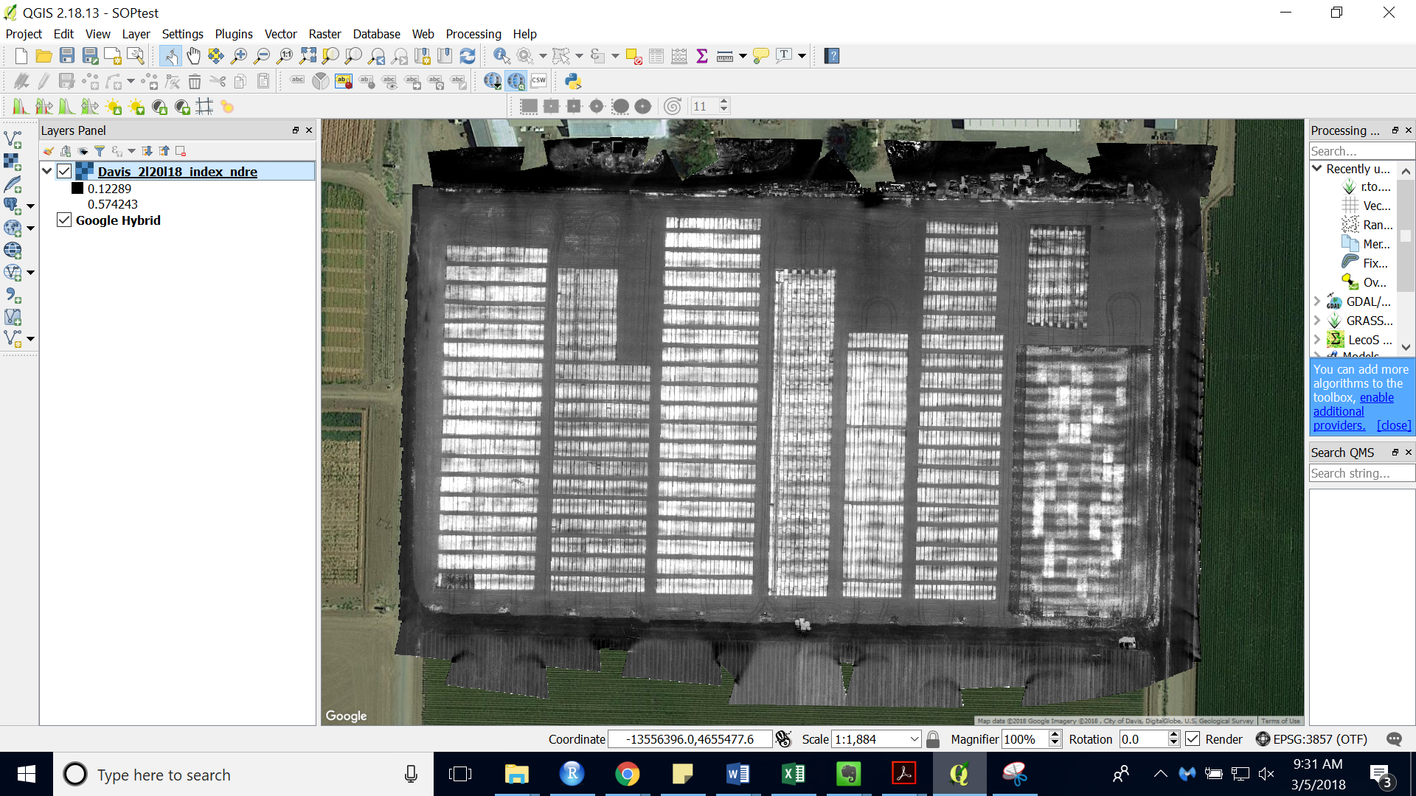

1. Clip the images to the area you are interested in. For accurate representation of the range of values that are in your study area this step is essential.
   * In the Processing Toolbox (“View” > “Panels” > “Toolbox”) search and select “Clip raster by extent”
   * Choose the correct raster layer
   * Click the “…” Next to clipping extent and choose “Select extent on Canvas” (See below)
   * Click “Run” and the “Close after it is finished running

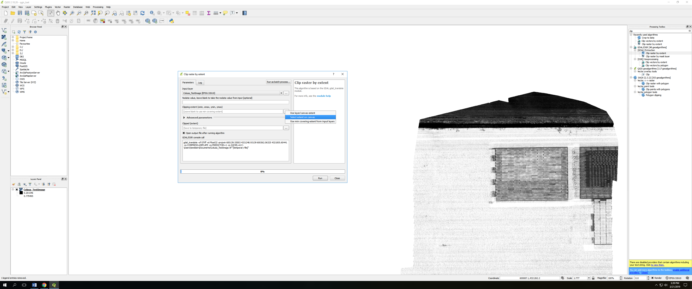

1. Right click the clipped image layer and choose “Properties”
2. In the “Style” tab (should open by default), under “Render type” choose “Singleband pseudocolor”

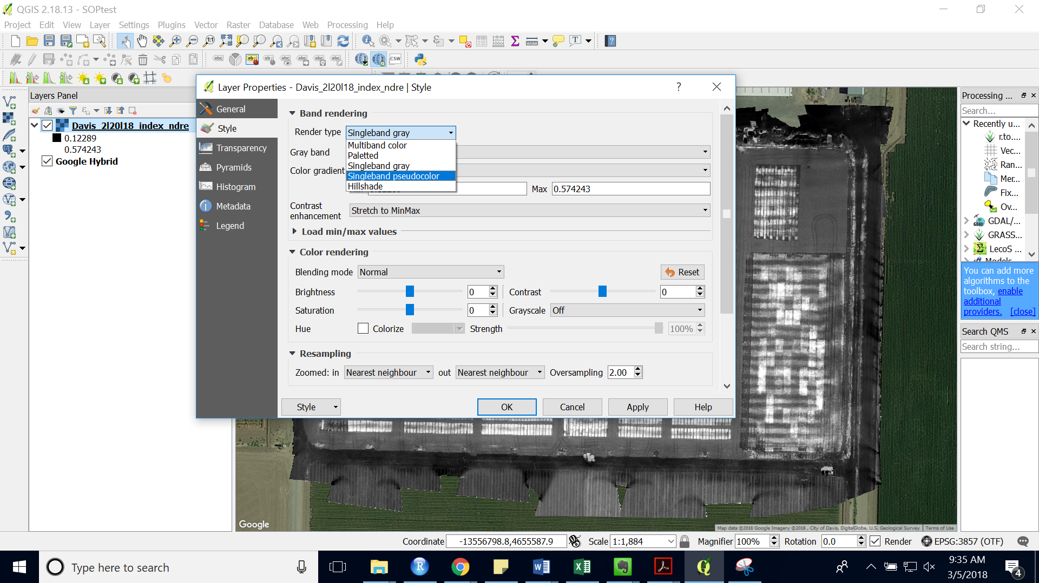

1. Set the Min and Max to cover the extent of values that you would like to see in an end product legend. These values should be close to the values that the system recognizes are max and min.
2. The “RdYlGn” coloring scheme is often used to show plant health
3. Change the “Mode” to be “Equal interval”
4. Change the number of classes to be >100

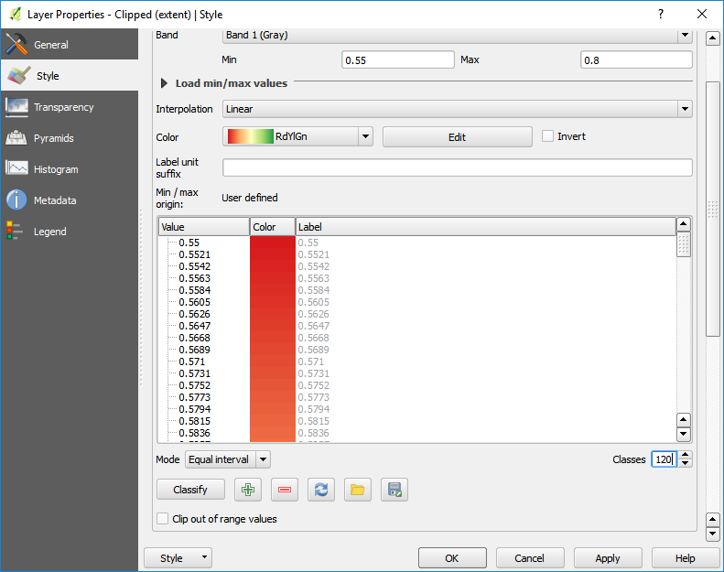

1. Scroll down and press the “Classify” button to color the image.
2. Press ok and your image should look like:

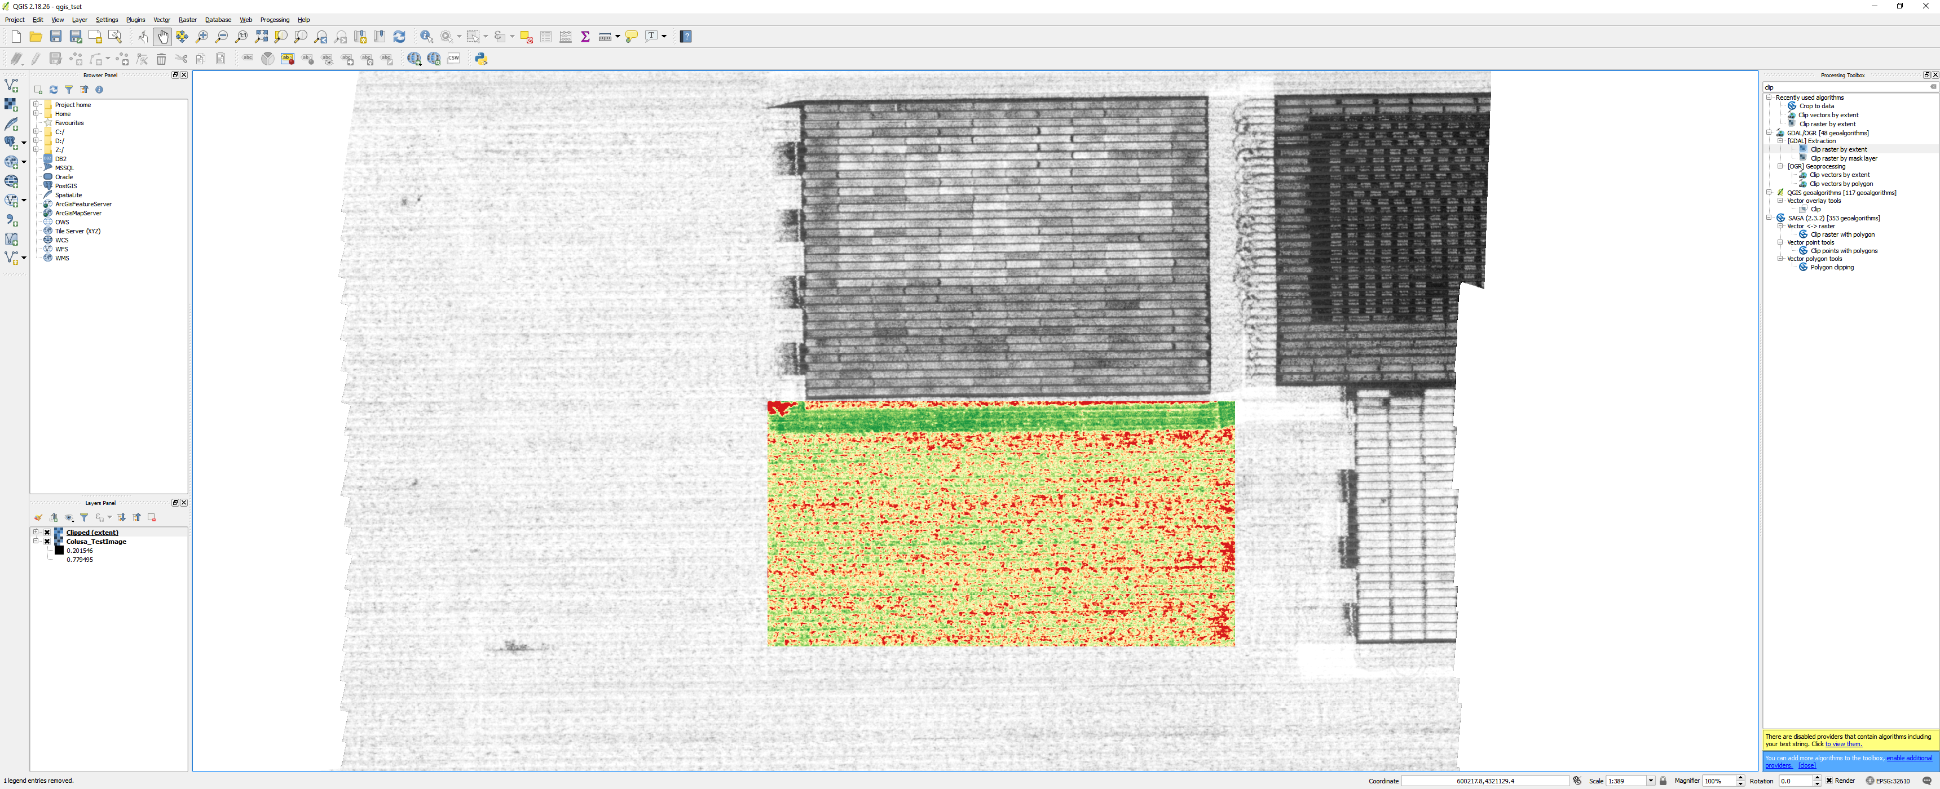

1. Once the map is colored how you wish under “Project” choose “New Print Composer”

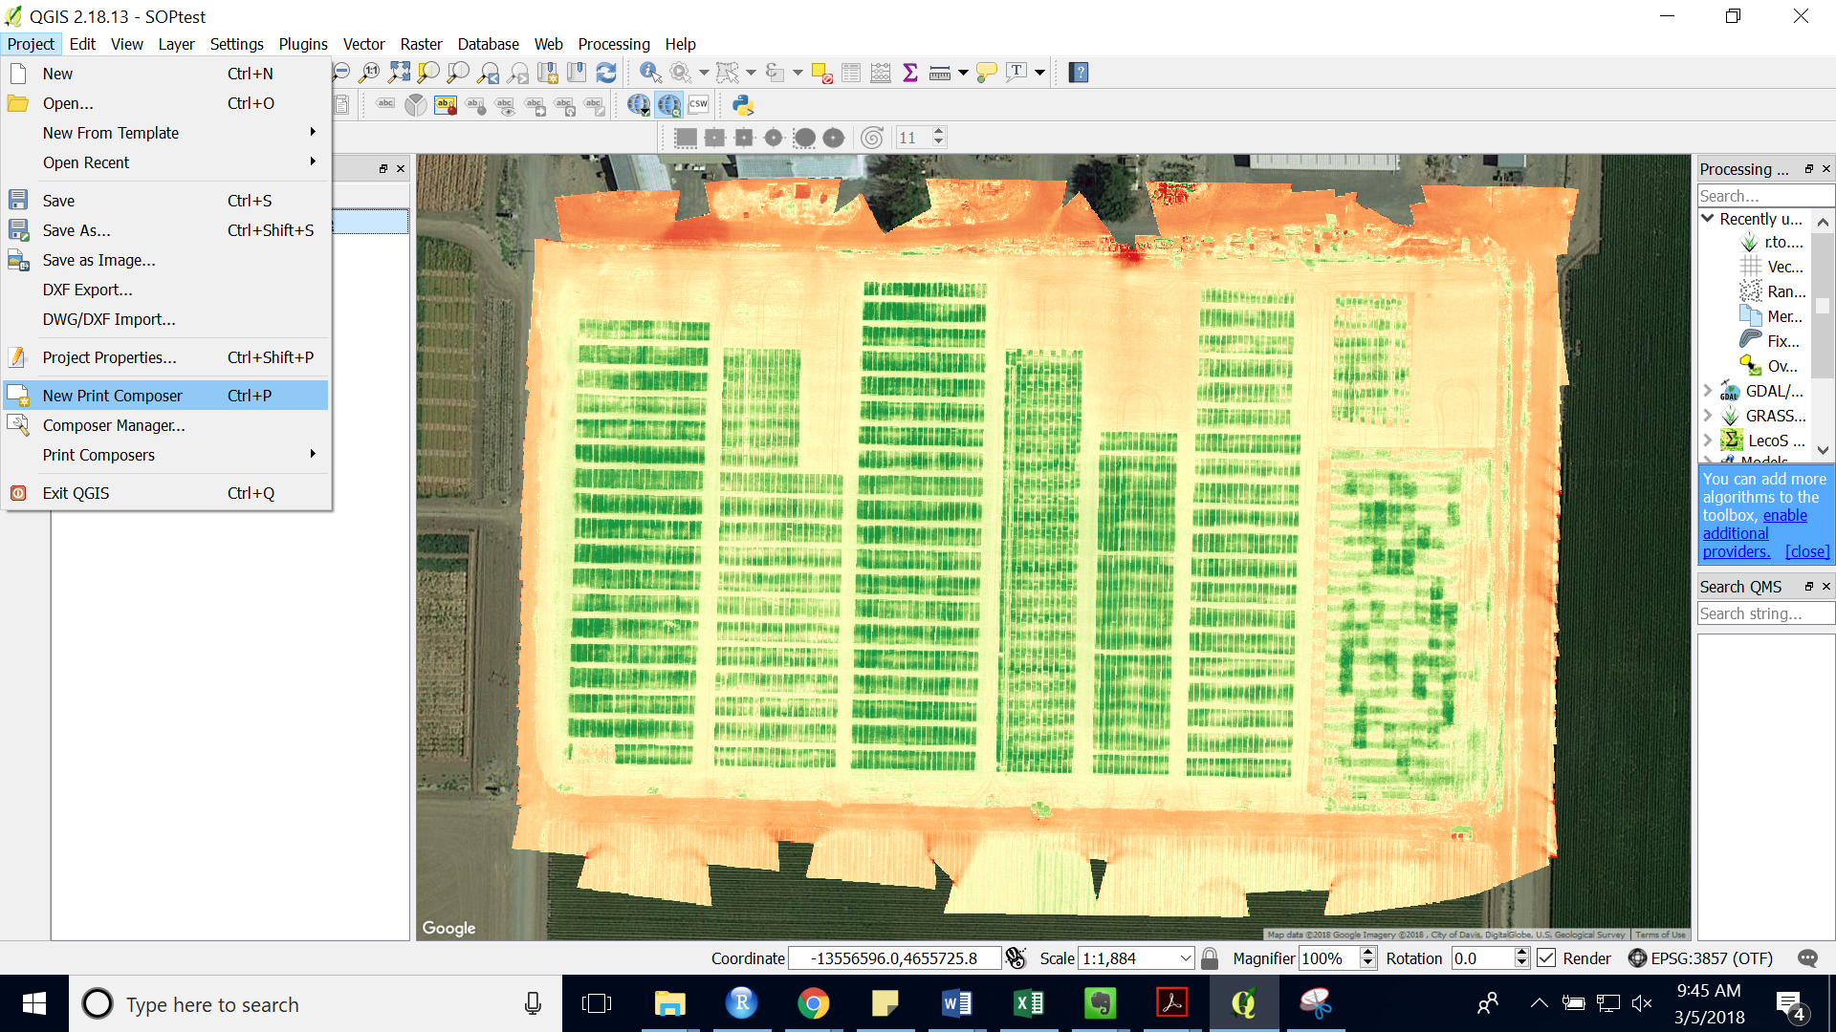

1. Enter a name for your map.
2. A new window with a blank map canvas should show up.

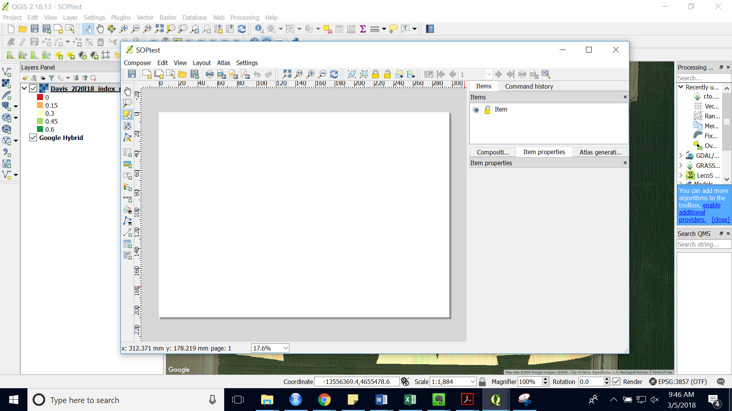

1. Under “Layout” choose “Add Map”.

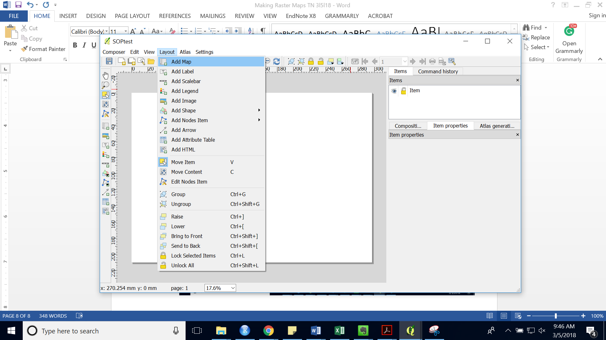

1. Draw a box for the map on the canvas.
2. You should now see the map on your map canvas.

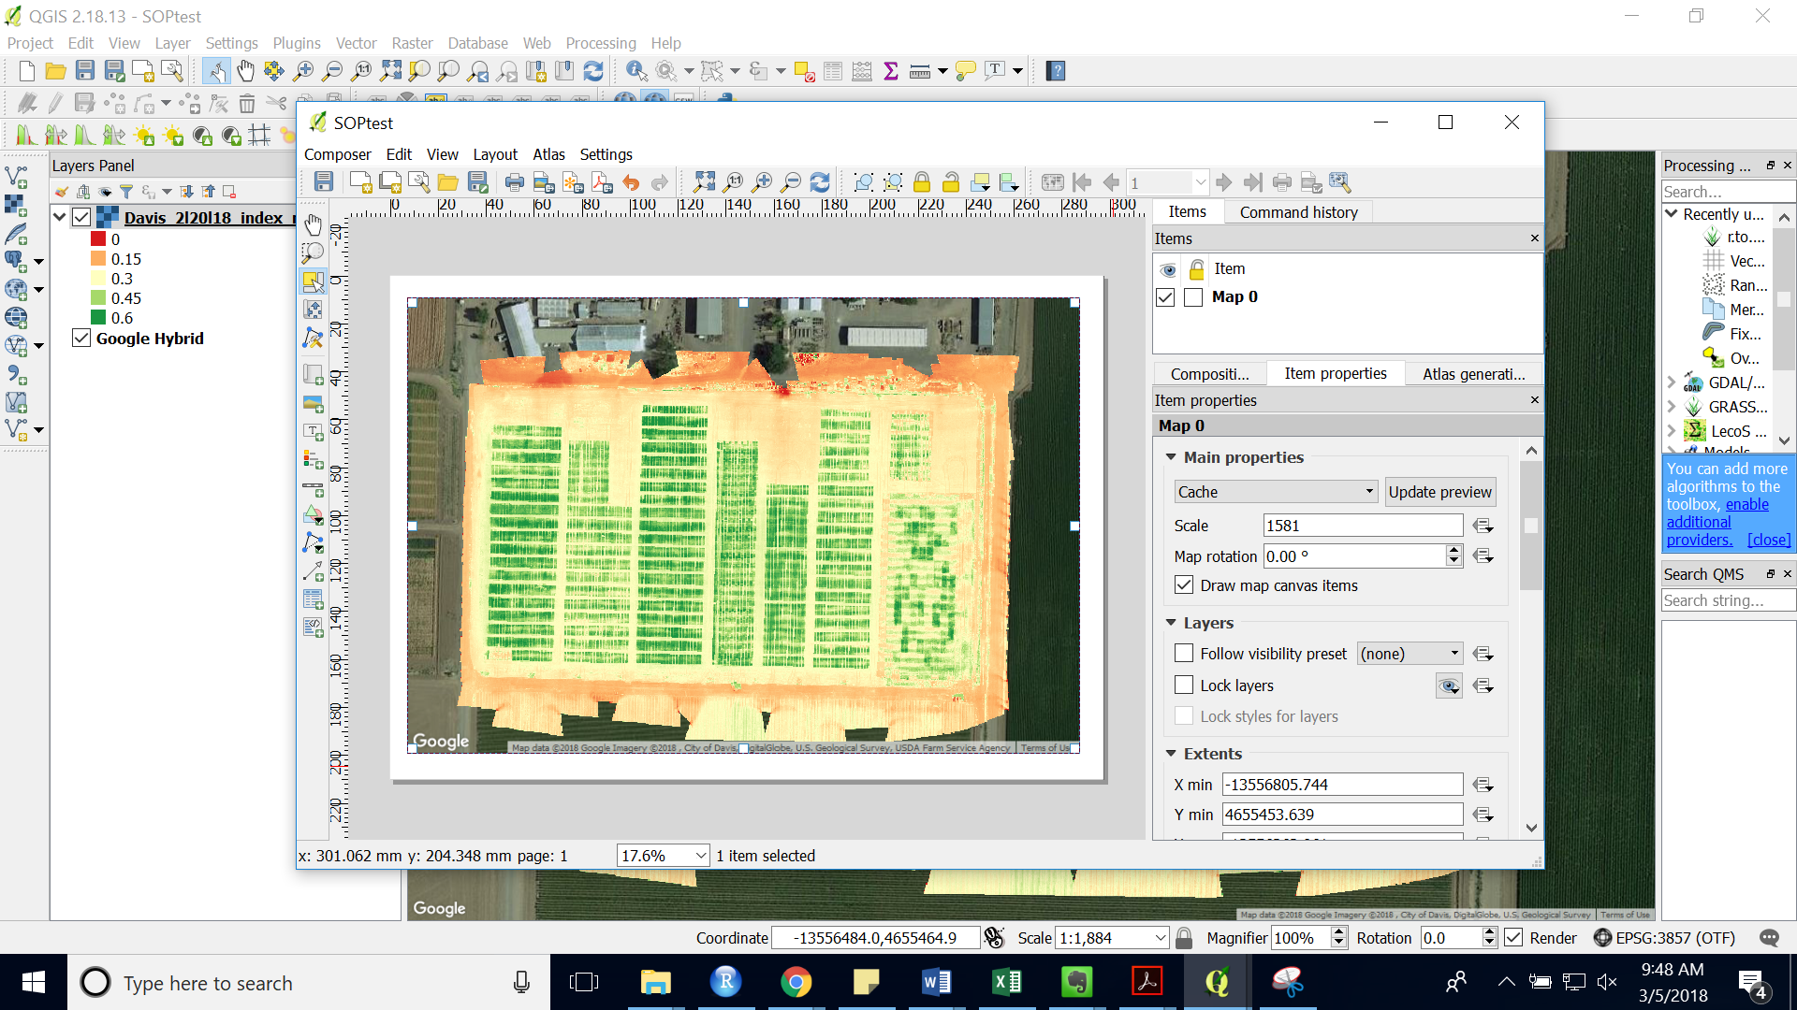

1. If you want to change the zoom/view of your map, click move item content on the left hand side.
2. Add a title or lab under “Layout” > “Add Label”
3. Draw a box on the map canvas where you want to place the label.

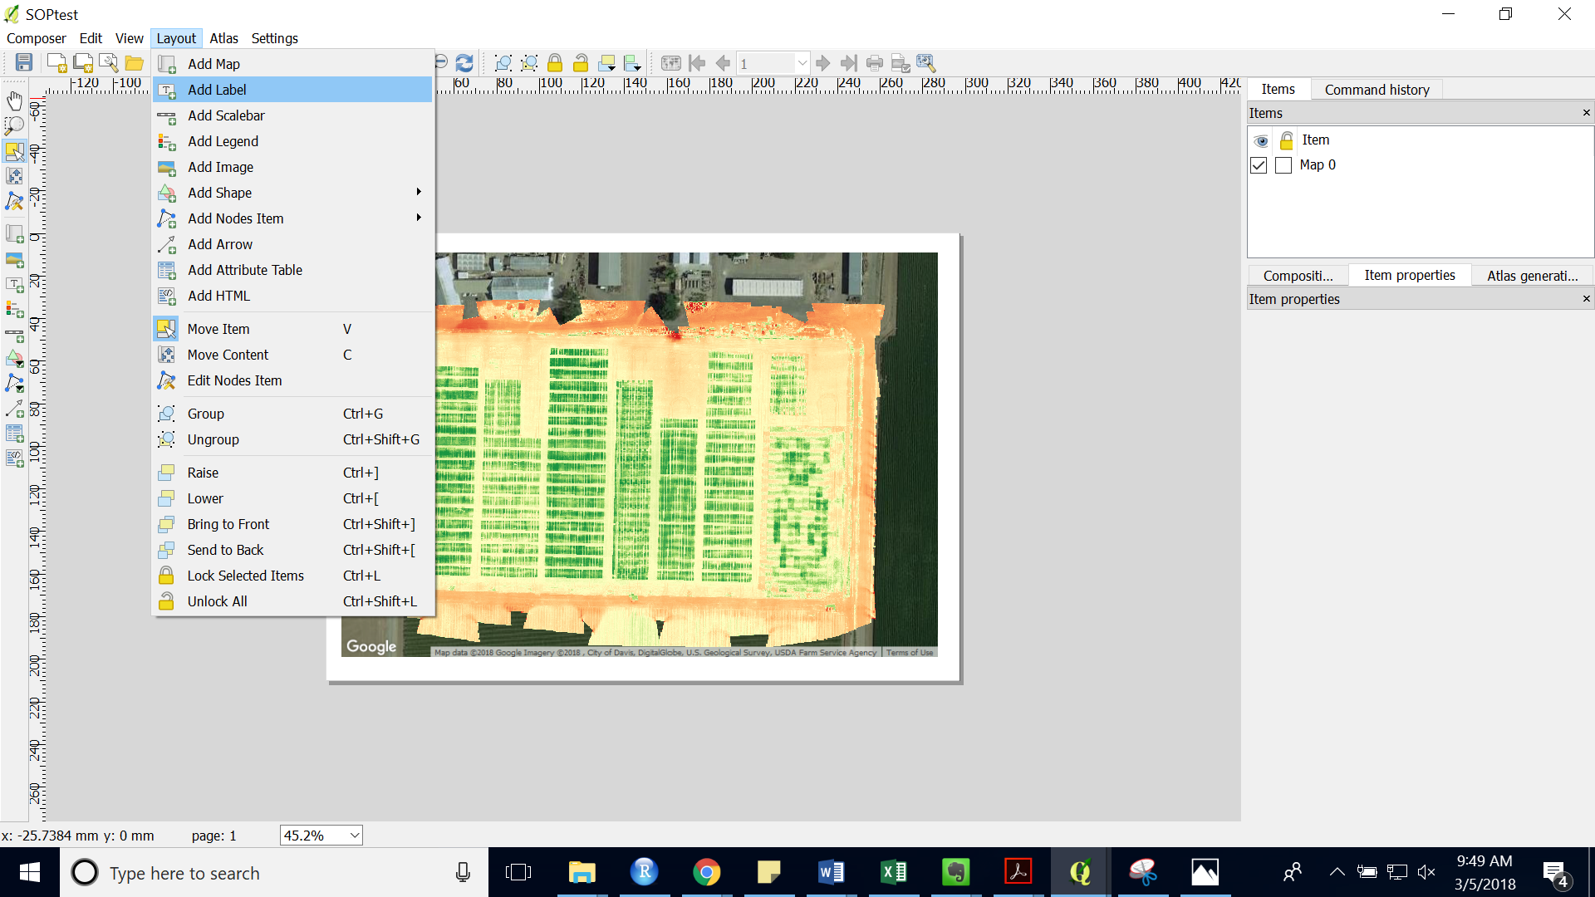

1. Edit the label in the right side bar.

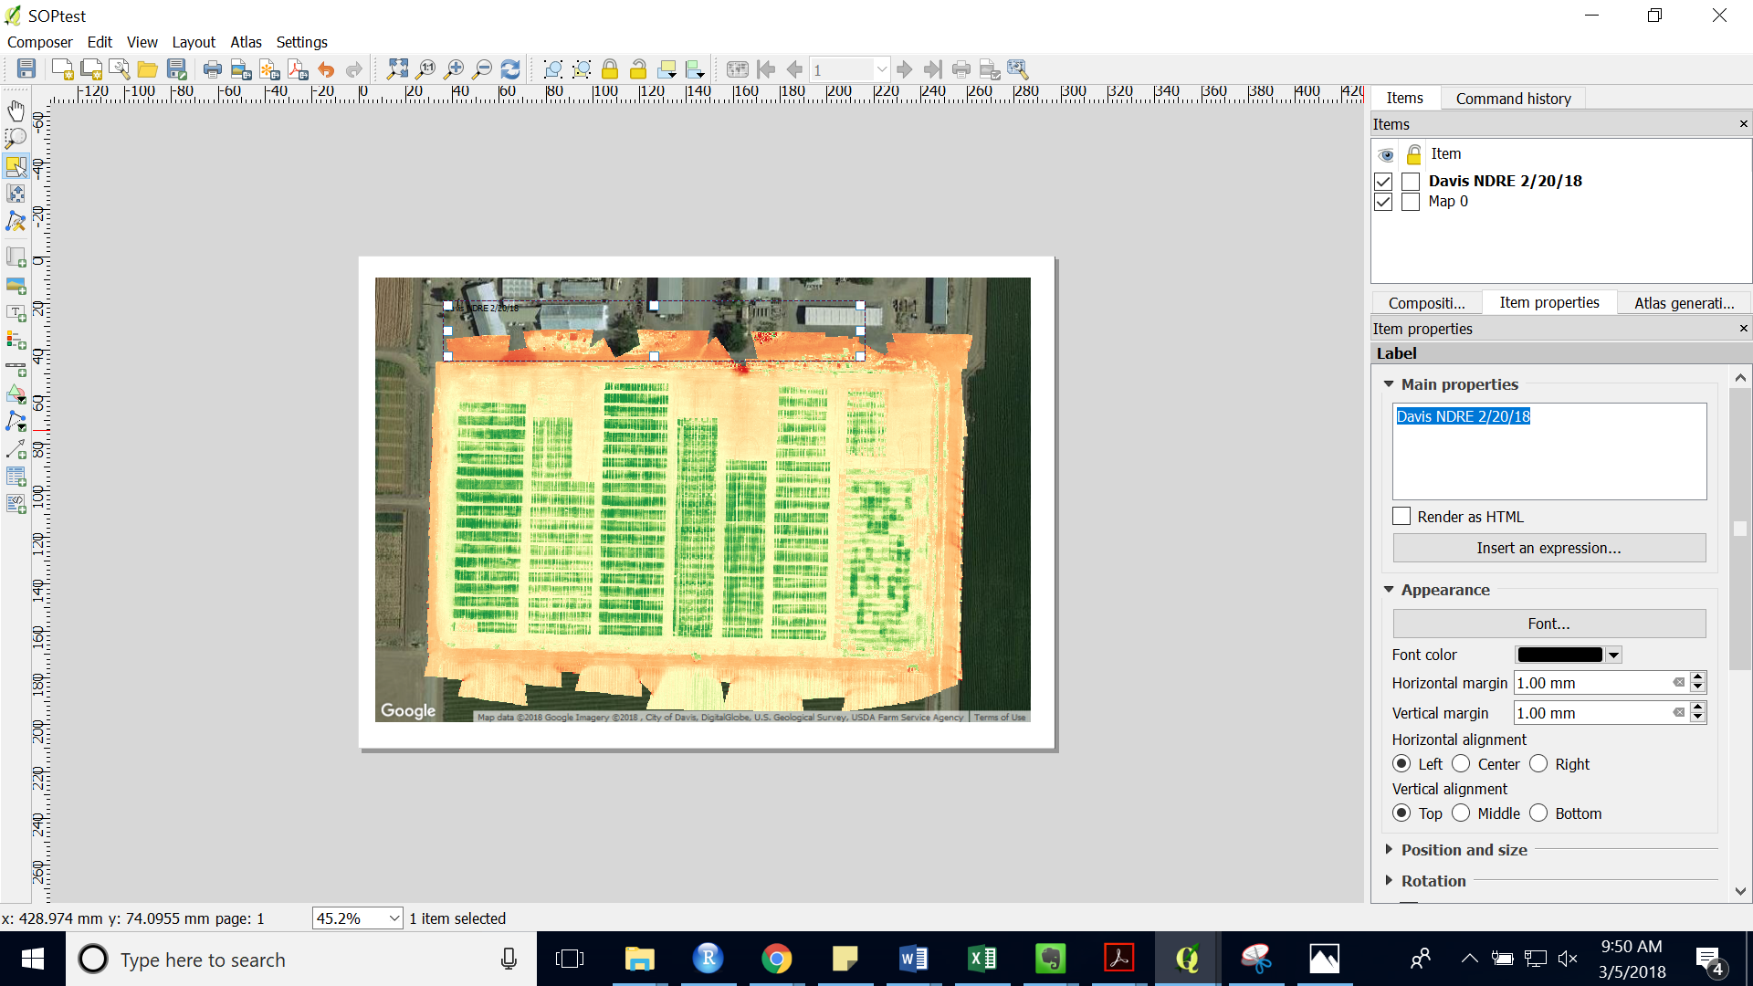

1. Under “Font…” edit the font style and size.

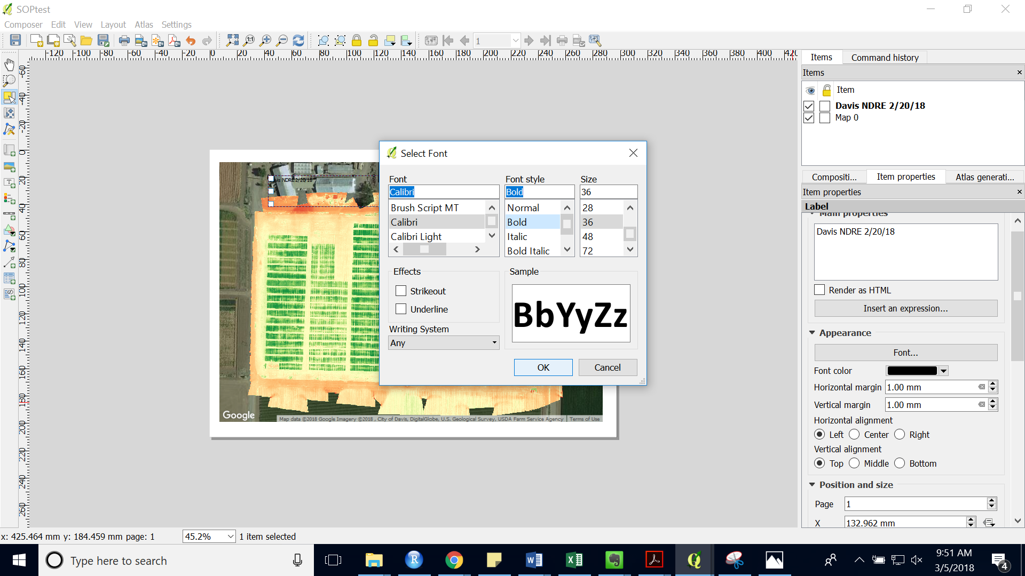

1. Add a background to the title or label by checking the “Background” tick box.

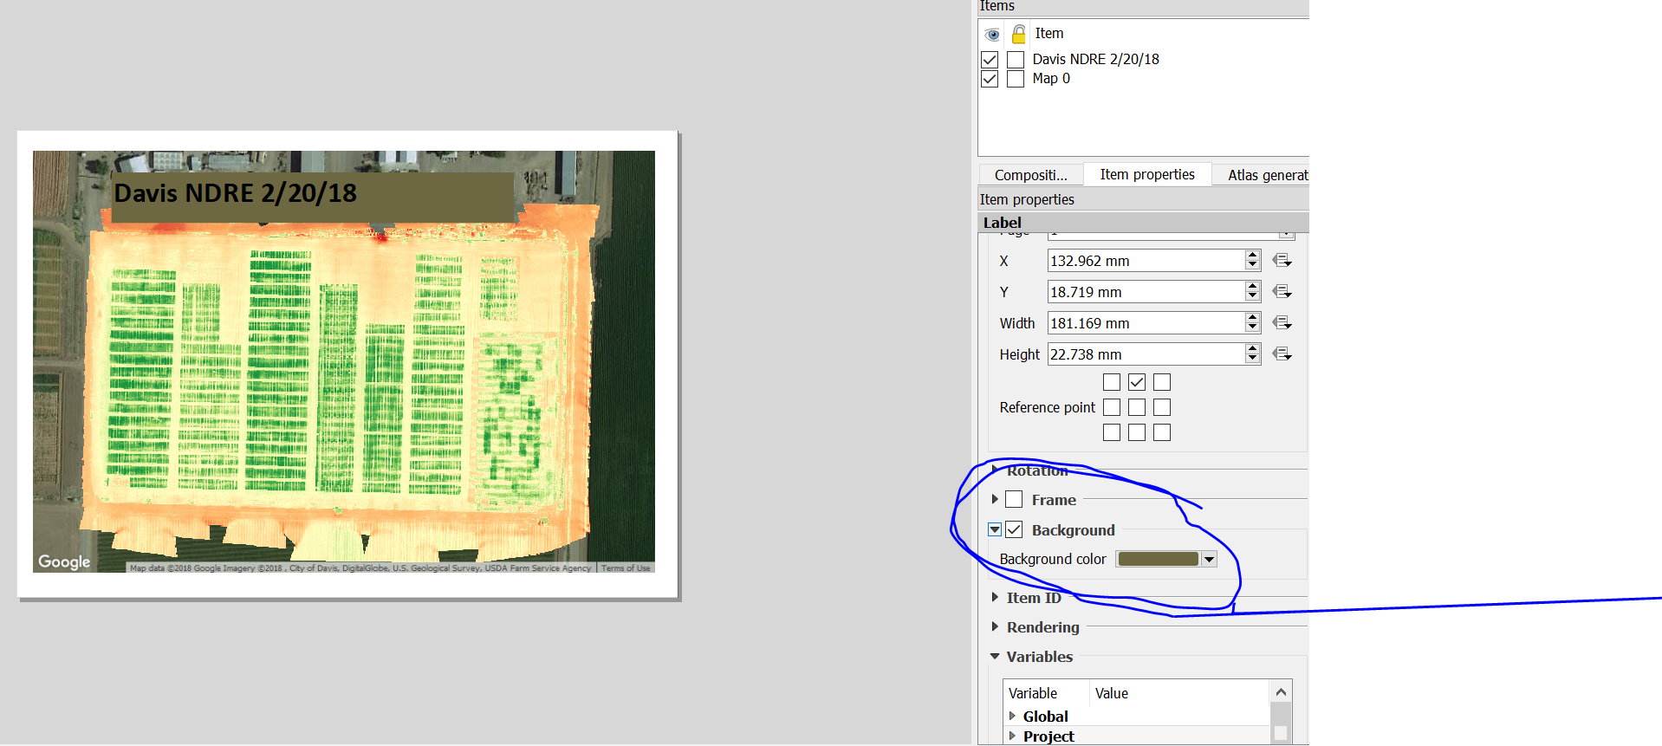

1. Change the alignment under “Horizontal Alignment”

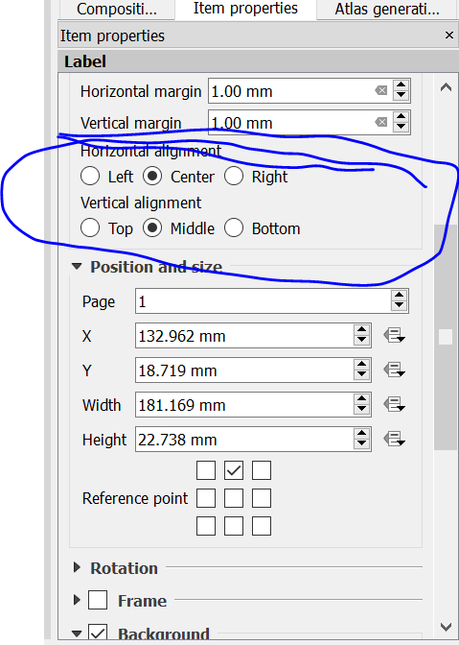

1. Add a scale bar under “Layout” > “Add Scalebar”
2. Draw a box where you would like to place the scalebar.

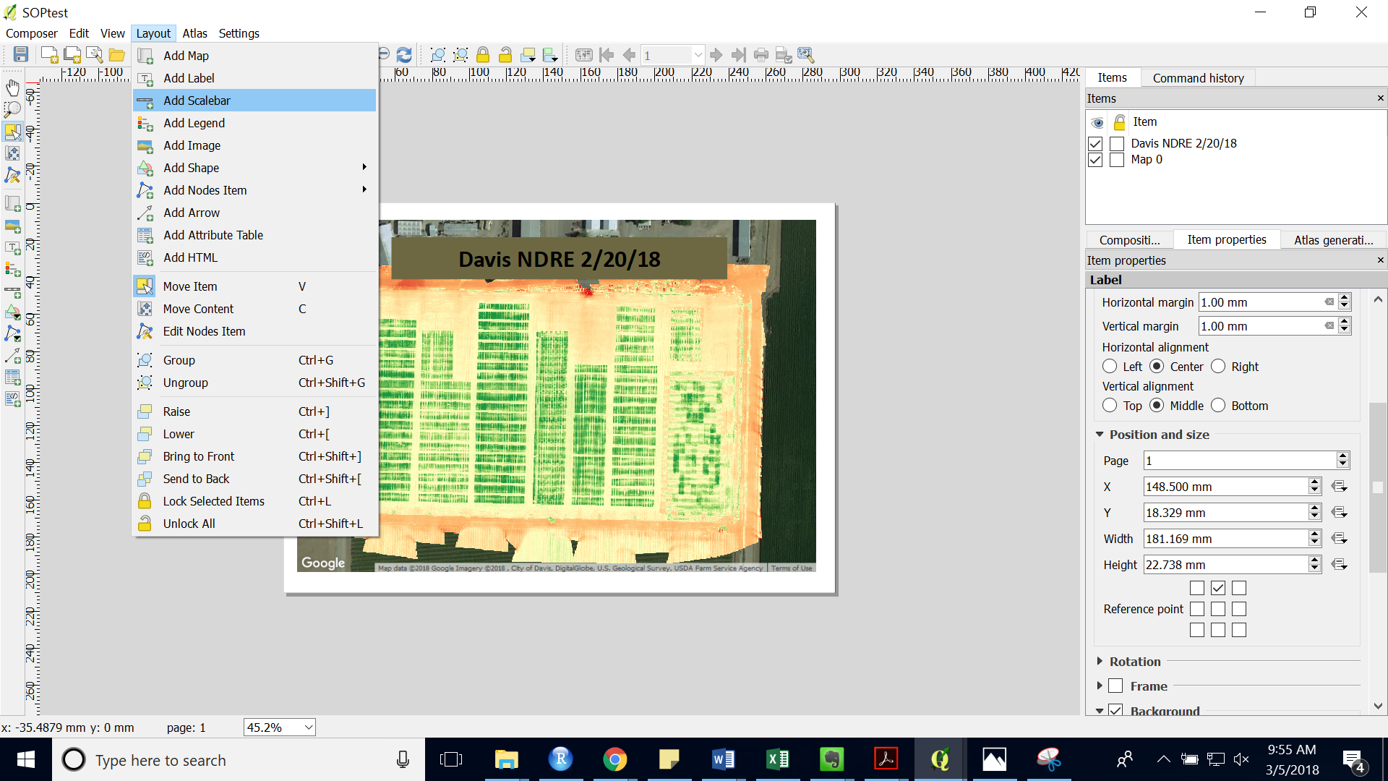

1. Edit the scalebar by highlighting it in the “Items” bar. You can change the units as well as the number of segments (see highlighted image).

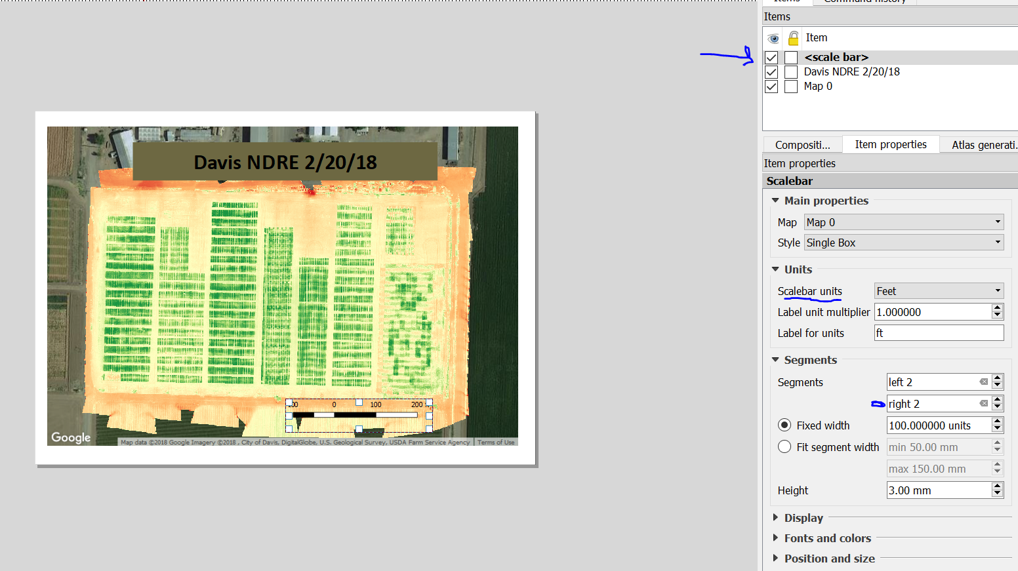

1. Add a legend under “Layout” > “Add Legend” Remember that to add an element you have to draw a box where you want to place the element. 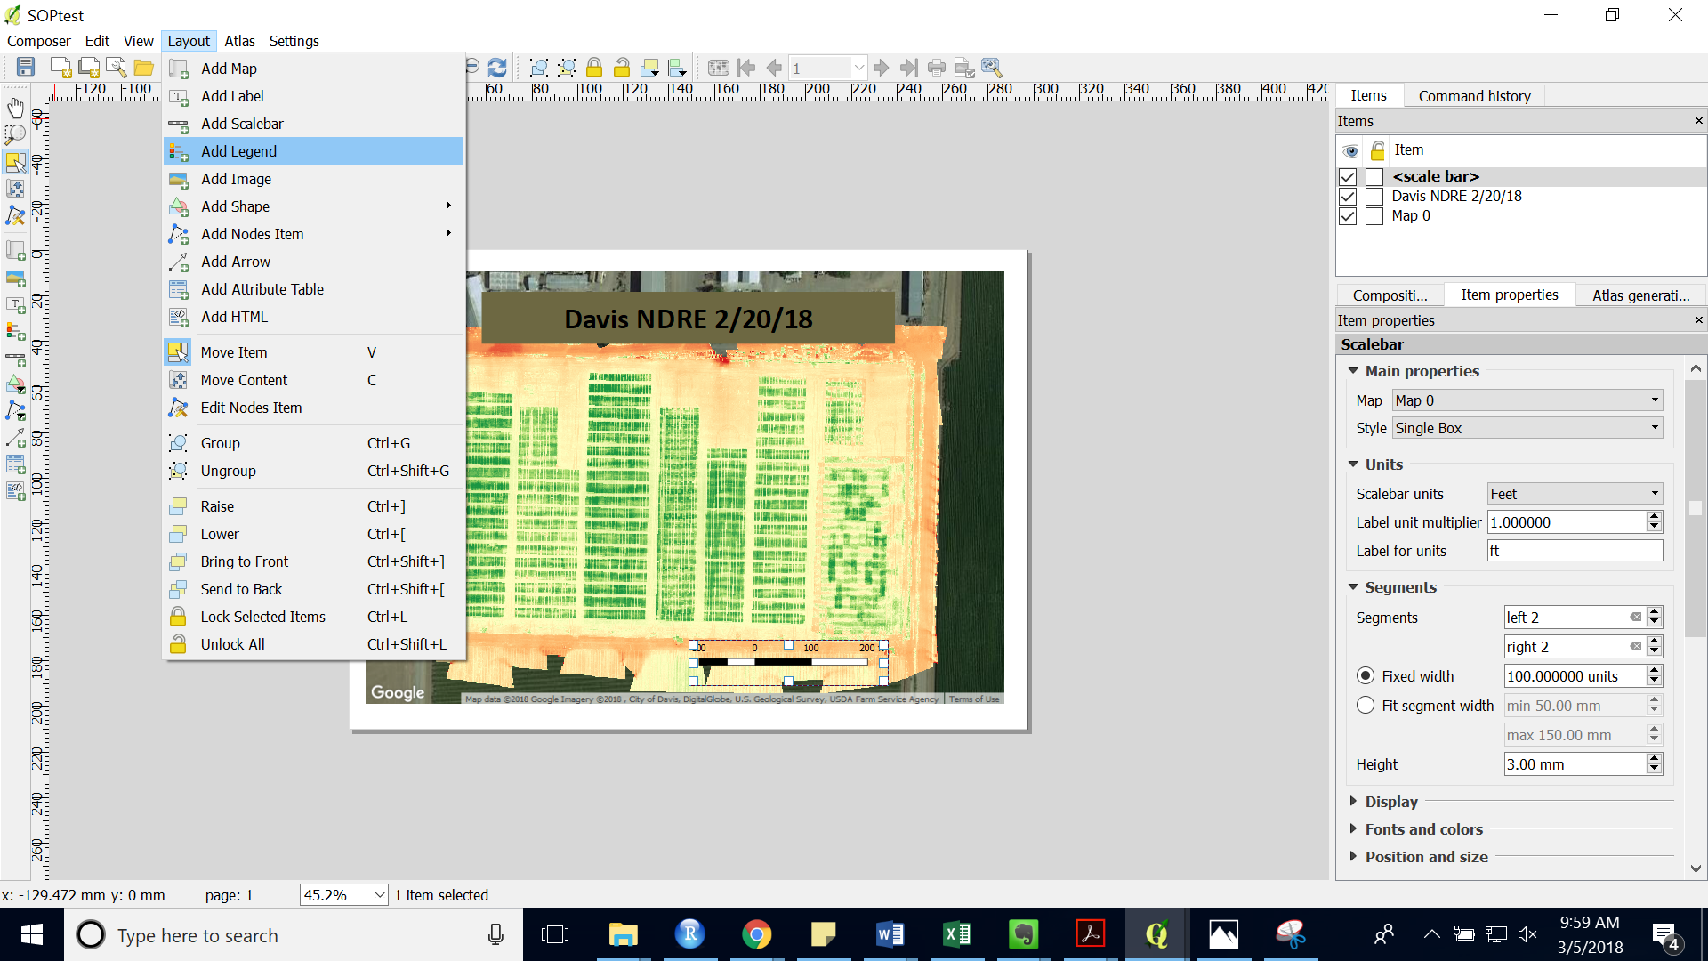
2. 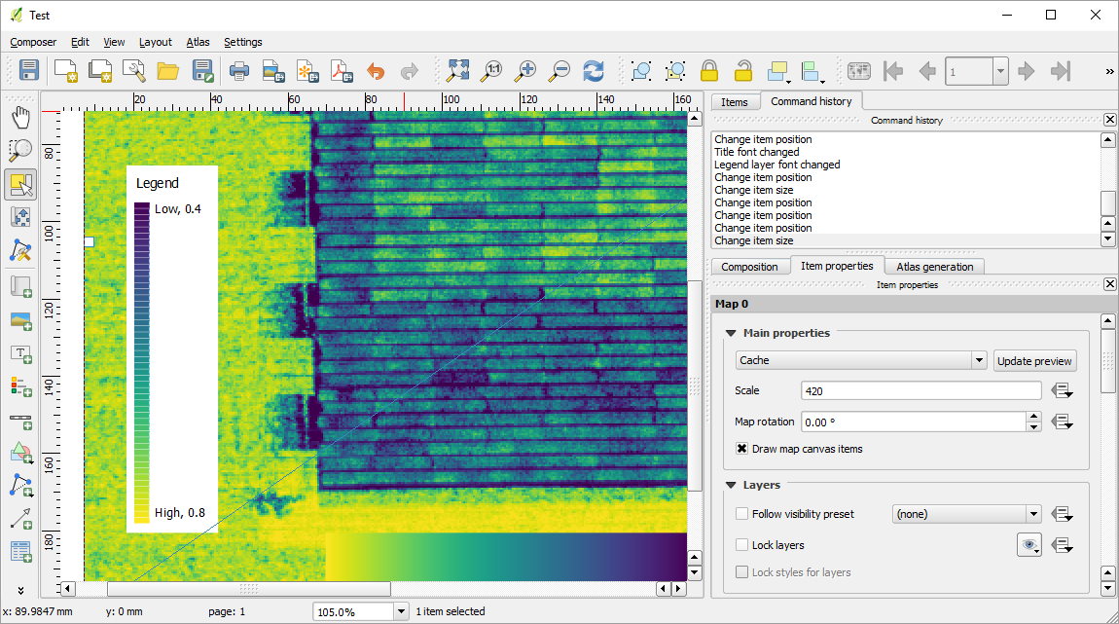In order to make the legend more readable when using many classes, make the font the same as the background color. Then reduce the font size to the minimum for everything and decrease the spacing for everything except box space to 0. Use add label to manually input words onto your legend.
3. Edit the layer label by editing back in the main QGIS window. Right click the layer and choose “Rename”

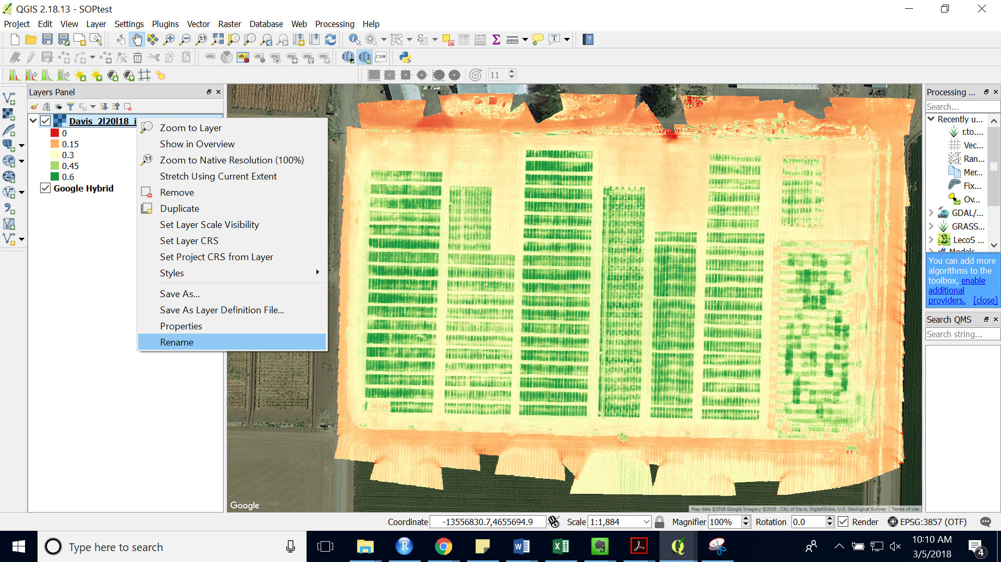

1. Your map should look like:

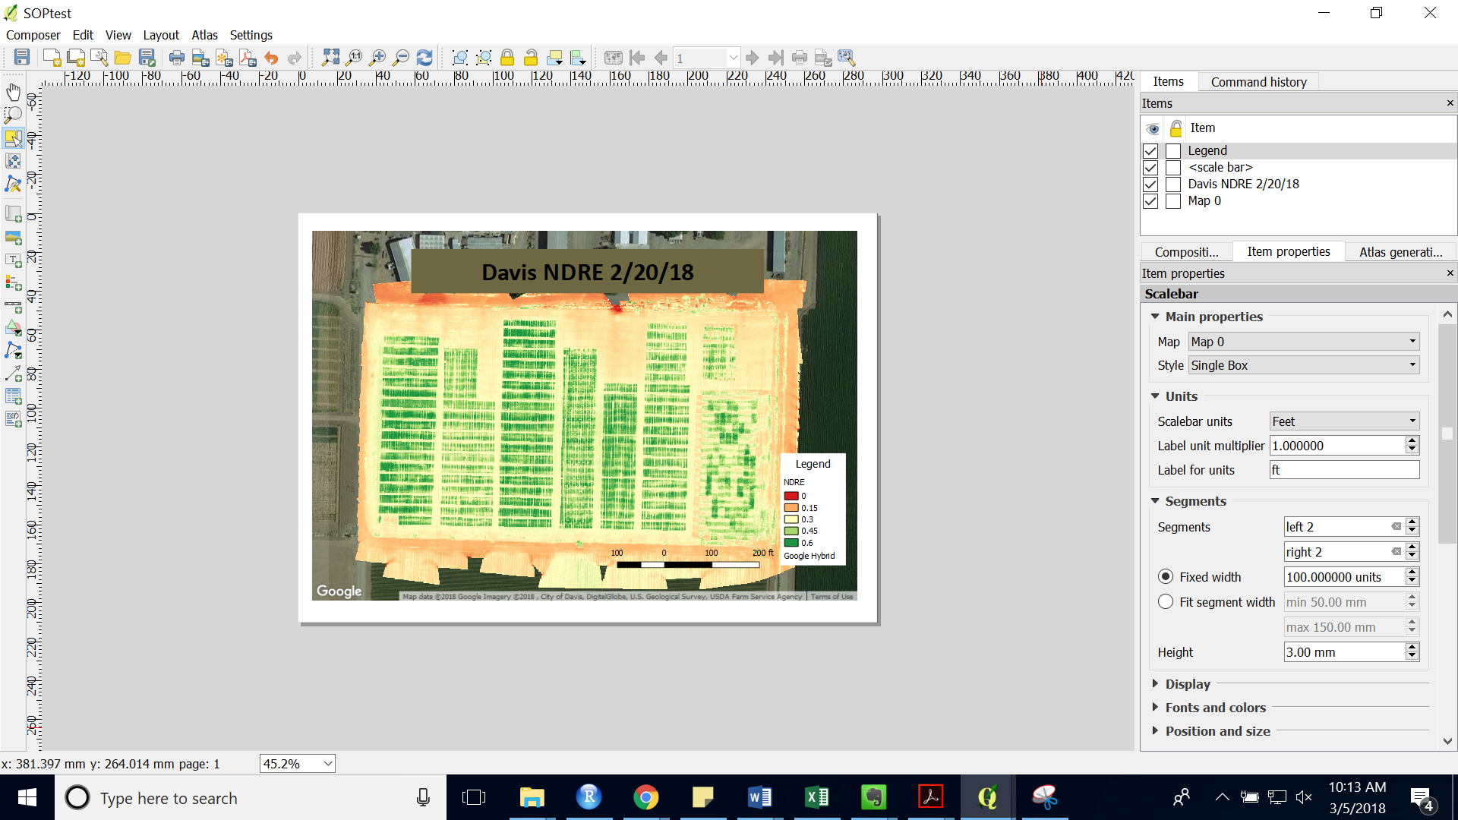

1. Add North arrow under “Layout” > “Add Images”.
2. Again, draw a box where you would like to place your image.
3. Under the Item panel open the “Search directories” and choose an arrow.

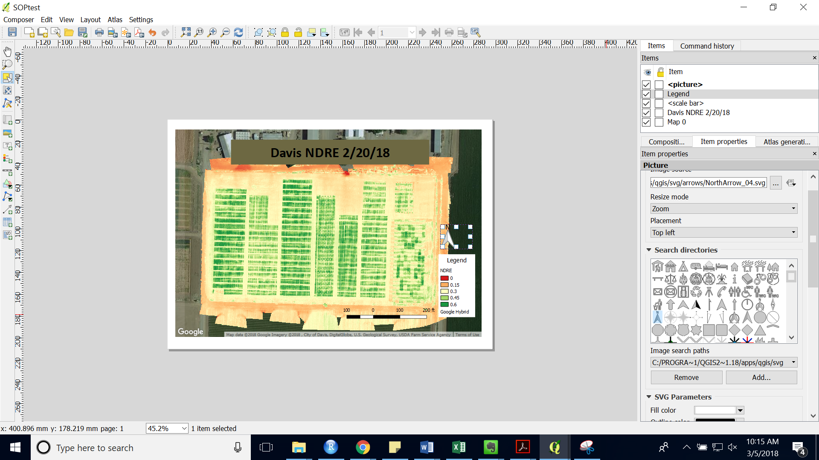

1. When you are finished editing your map under “Composer” choose “Export as Image…” you can also export as a PDF by choosing “Export as PDF…”

